IoT-Based Smart Garden Irrigation System with Real-Time Monitoring Using Blynk App

Submitted By
Student Name | Student ID
Md Junayed Bin Karim | 0242220005101667
Md.Rakibul Alam Siam | 242220005101676
Mahir Labib | 242220005101627

LAB PROJECT REPORT
This Report Presented in Partial Fulfillment of the course CSE234: Embedded System & IoT Lab in the Computer Science and Engineering Department

DAFFODIL INTERNATIONAL UNIVERSITY
Dhaka, Bangladesh
15 Apri, 2025
DECLARATION
We hereby declare that this lab project has been done by us under the supervision of MD Taslim Arif, Lecturer, Department of Computer Science and Engineering, Daffodil International University. We also declare that neither this project nor any part of this project has been submitted elsewhere as lab projects.
Submitted To:
Md Taslim Arif
Lecturer
Department of Computer Science and Engineering Daffodil
International University
Submitted by
Junayed Bin Karim
0242220005101667
Dept. of CSE, DIU

COURSE & PROGRAM OUTCOME
The following course have course outcomes as following:
Table 1: Course Outcome Statements
CO’s | Statements
CO1 | Able to develop IoT-based solutions using ESP32 and sensors
CO2 | Able to integrate cloud platforms like Blynk for remote monitoring
CO3 | Able to implement automation in real-life applications

Table of Contents
Declaration i Course & Program Outcome ii
1 Introduction 1 1.1 Introduction 1 1.2 Motivation 1 1.3 Objectives 1 1.4 Feasibility Study 1 1.5 Gap Analysis 1 1.6 Project Outcome 2
2 Proposed Methodology/Architecture 3 2.1 Requirement Analysis & Design Specification 3 2.1.1 Overview 3 2.1.2 Proposed Methodology/ System Design 3 2.1.3 UI Design 3 2.2 Overall Project Plan 3
3 Implementation and Results 5 3.1 Implementation 5 3.2 Performance Analysis 5 3.3 Results and Discussion 5
4 Engineering Standards and Mapping 6 4.1 Impact on Society, Environment and Sustainability 6 4.1.1 Impact on Life 6 4.1.2 Impact on Society & Environment 6 4.1.3 Ethical Aspects 6 4.1.4 Sustainability Plan 7 4.2 Project Management and Team Work 7 4.3 Complex Engineering Problem 7 5 Conclusion 8 5.1 Summary 8 5.2 Limitation 8 5.3 Future Work 8
References 9
Chapter 1
Introduction

1.1 Introduction
This project introduces an IoT-Based Smart Garden Irrigation System integrated with real-time monitoring capabilities through the Blynk mobile application. The primary goal is to automate the watering process of a garden by continuously sensing the soil moisture level using a sensor and then activating a water pump when necessary. This approach not only optimizes water usage but also significantly reduces the need for manual intervention, making garden maintenance more efficient and sustainable. The use of IoT technology ensures that the system is smart, responsive, and accessible remotely.

1.2 Motivation
In today’s world, urbanization is increasing rapidly, often leading to the reduction of natural green spaces. Maintaining home gardens and small green areas has become both important and challenging. Traditional watering practices are usually manual, time-consuming, and inefficient, often resulting in over-watering or under-watering of plants. This inspired the development of a system that could monitor the condition of the soil in real time and respond accordingly. The motivation behind this project stems from the need to develop smart, eco-friendly, and user-friendly solutions for sustainable gardening in modern living environments.

1.3 Objectives
The core objectives of the project are as follows:
- Automate the garden watering process based on the real-time soil moisture level detected by sensors.
- Utilize the ESP32 microcontroller to provide IoT connectivity, enabling data transmission and control operations.
- Enable remote monitoring and control of the irrigation system through the Blynk mobile application, allowing users to manage the system from anywhere.
- Reduce water wastage and manual labor while ensuring the healthy growth of plants.

1.4 Feasibility Study
This project has been carefully designed to be cost-effective, accessible, and practical for small-scale use. All the components used — such as the ESP32 board, soil moisture sensor, relay module, and water pump — are affordable and readily available in local and online markets. The system requires basic technical skills in hardware connections and programming, which makes it feasible for students, hobbyists, or gardeners with minimal technical experience. Furthermore, the Blynk app provides a user-friendly platform for visualizing data and controlling devices, enhancing usability even further.

1.5 Gap Analysis
Most traditional irrigation systems rely on manual operation or simple timed mechanisms that do not take the actual condition of the soil into account. This leads to inefficiencies in water usage and often poor plant health. Moreover, these systems usually lack remote access and real-time feedback, which limits their functionality in today’s connected world.
This project bridges the gap by introducing a smart, responsive, and remotely controllable irrigation system. It not only considers real-time soil moisture data but also provides users with the ability to monitor and control the system from any location via a smartphone.

1.6 Project Outcome
The successful completion of this project results in:
- A fully functional, automated irrigation system capable of independently managing watering schedules based on soil moisture levels.
- Real-time monitoring of soil conditions using sensors, with data visualized through a smartphone app.
- A user interface built using the Blynk mobile app, allowing remote control, monitoring, and manual override functions to ensure flexibility and convenience for the user.
This project demonstrates the practical application of IoT in smart agriculture and urban gardening, making it a promising solution for the future.

Chapter 2
Proposed Methodology

2.1 Requirement Analysis & Design Specification

2.1.1 Overview
The system is designed for real-time soil moisture monitoring and irrigation control. It integrates various sensors and actuators with an ESP32 microcontroller. The collected data is transmitted to the Blynk app, which provides a real-time monitoring dashboard and the option for manual control of the water pump.

2.1.2 Components Used
- ESP32 Board – The central controller handling data collection and communication .
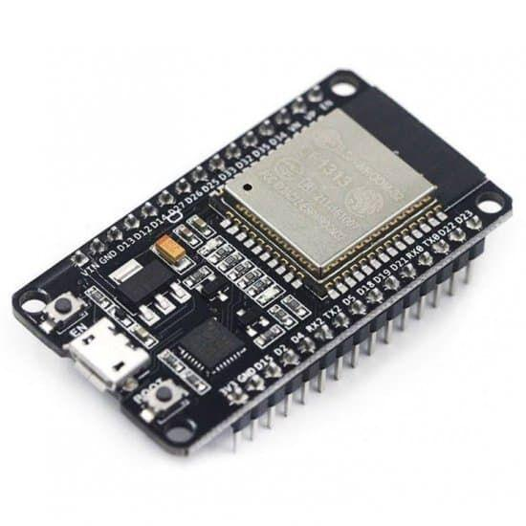
- Soil Moisture Sensor – Measures soil moisture levels.\
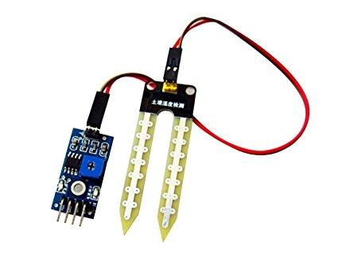
- Relay Module – Controls the water pump based on sensor input or user commands.
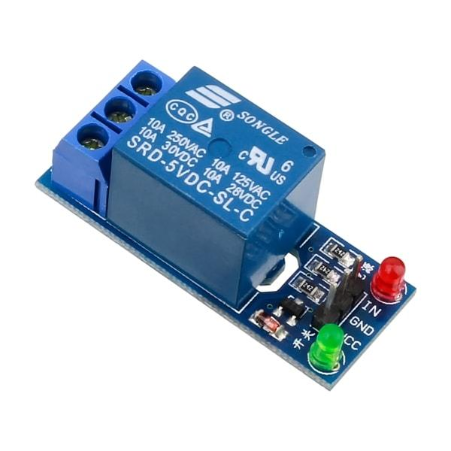
- LCD with I2C Module – Displays real-time sensor data locally.
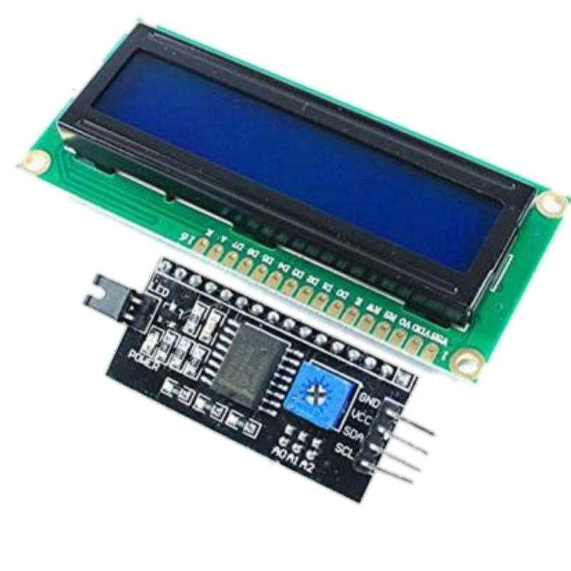
- Breadboard – Used for prototyping and connecting components.
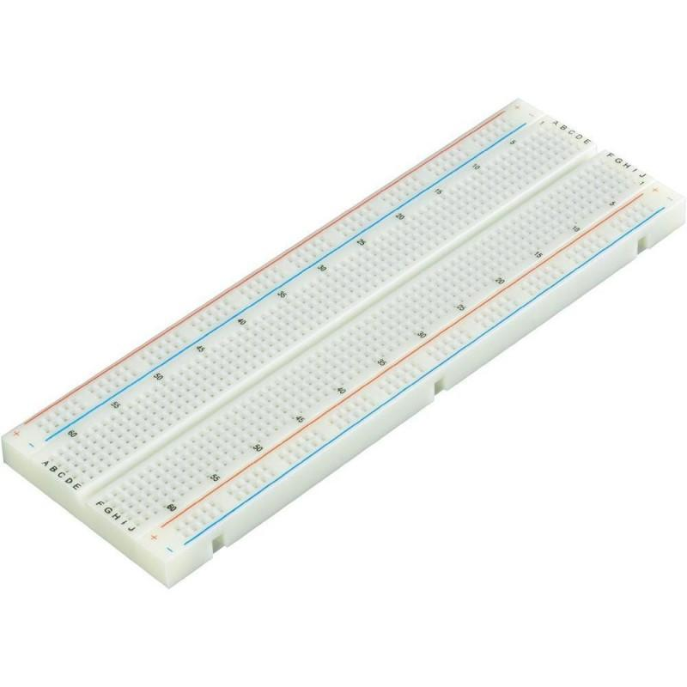
- Jumper Wires – Enables electrical connections between components.
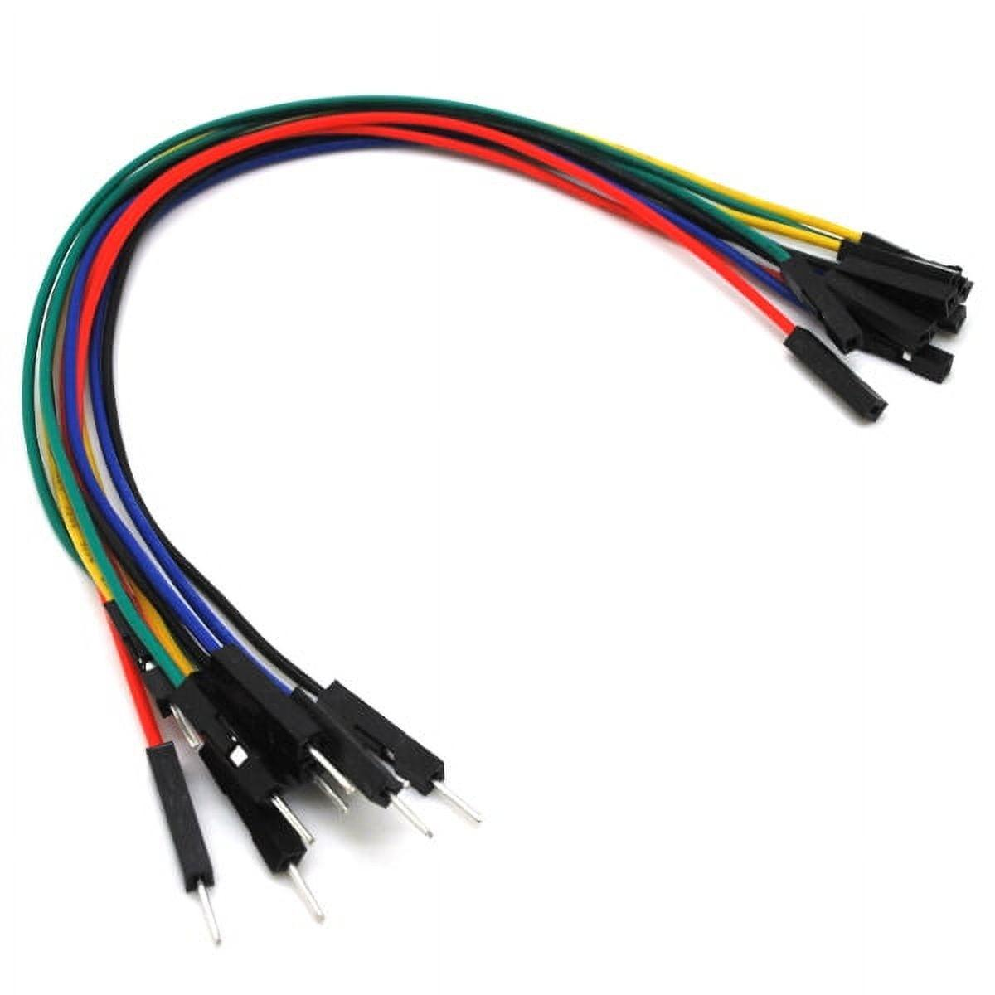
- Mini Water Pump and Pipe – Used for irrigating the soil.
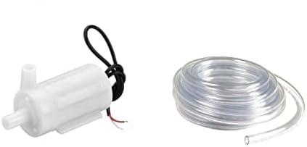
- Li-ion Batteries and Holder – Provides portable power supply.
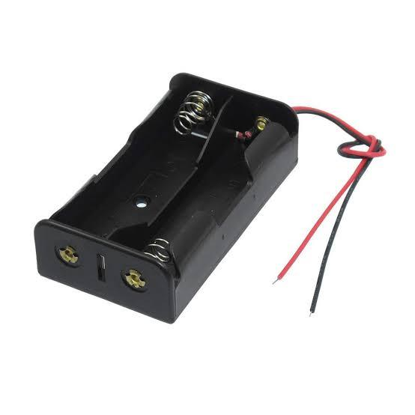

2.1.3 UI Design
The Blynk app serves as the user interface, offering a virtual dashboard with the following features:
- Real-time soil moisture level display.
- Water pump status (ON/OFF).
- Manual control button to override automatic irrigation.
- Visual widgets like gauges, switches, and notification alerts.
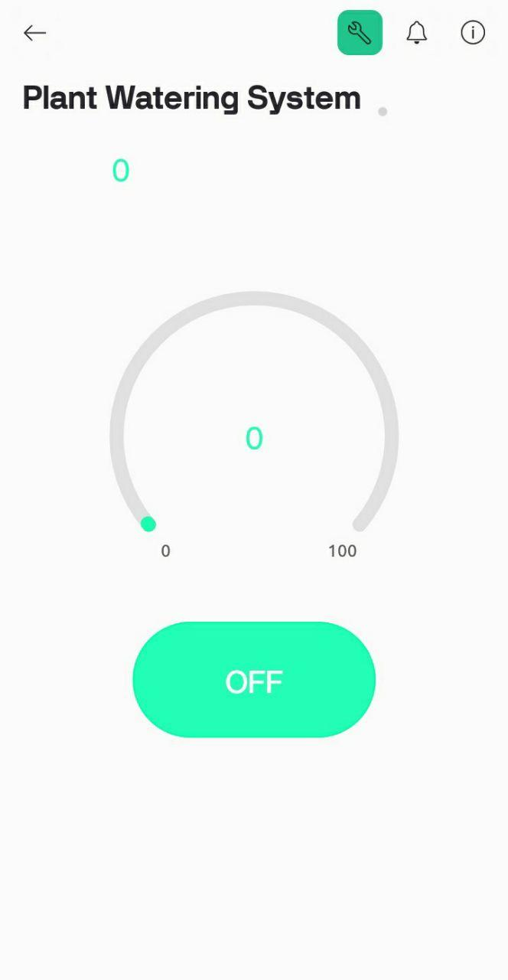

2.1.4 Methodology Flow Chart :

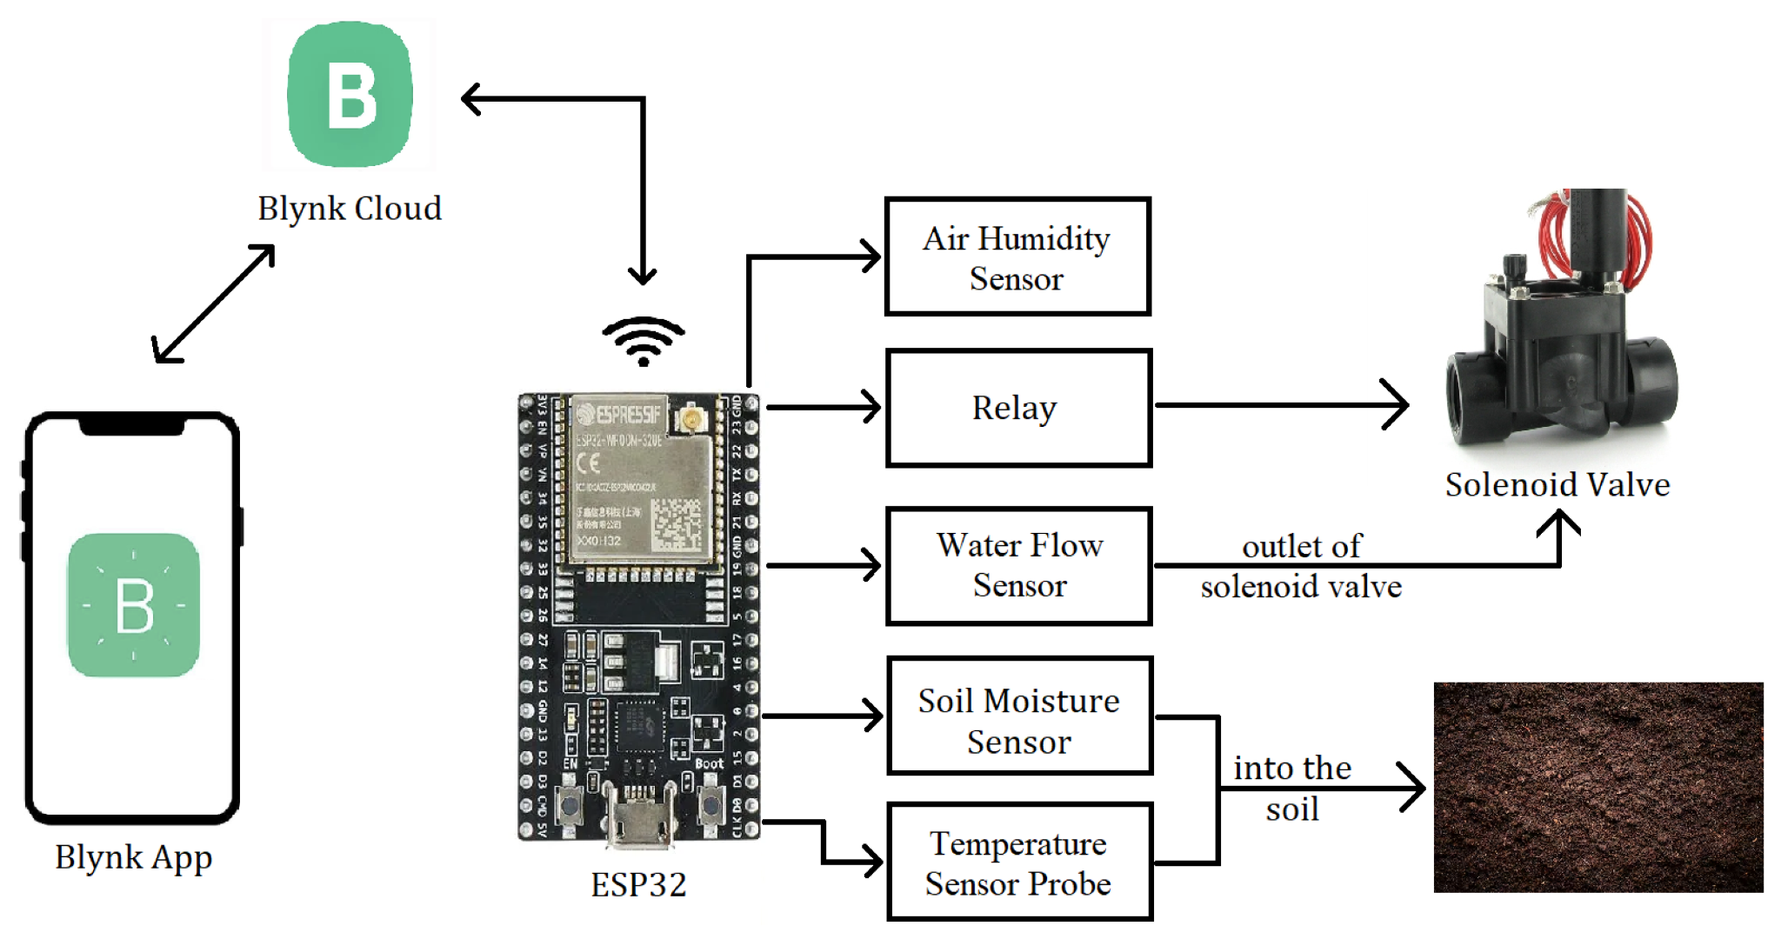
Figure 2.1: Methodology Flow Chart

2.1.5 Circuit Diagram:
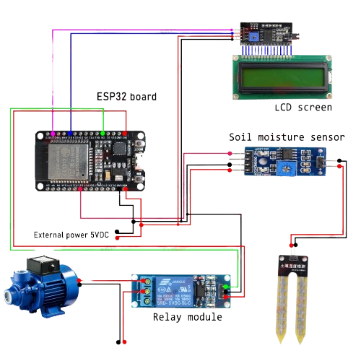
Figure 2.2: Circuit Diagram

2.2 Overall Project Plan
Task | Start Date | End Date | Status
Component Setup | 2025-03-20 | 2025-03-25 | Completed
Programming | 2025-04-01 | 2025-04-05 | Completed
Testing & Debugging | 2025-04-06 | 2025-04-07 | Completed
Final Deployment | 2025-04-12 | 2025-04-13 | Completed

Figure 2.3: Project Timeline Data

Chapter 3
Implementation and Results

3.1 Implementation
The smart irrigation system was developed using a combination of hardware components and software programming. The Arduino IDE was used to write and upload the code to the ESP32 microcontroller. The main implementation steps include:
- The system logic was written in Arduino C/C++, enabling integration of sensors, actuators, and communication modules.
- A soil moisture sensor continuously measures the soil's water content and provides real-time analog input to the ESP32.
- If the moisture level drops below a defined threshold, the ESP32 activates the relay module, which turns on the mini water pump to irrigate the soil.
- A 16x2 LCD with an I2C interface displays the current moisture level and the pump status.
- The Blynk mobile application communicates with the ESP32 over Wi-Fi, providing live data monitoring and manual control of the pump.
This implementation ensures real-time automation while allowing users to override the system manually when needed.

Step 1:
Firstly, install the ESP32 board on the breadboards
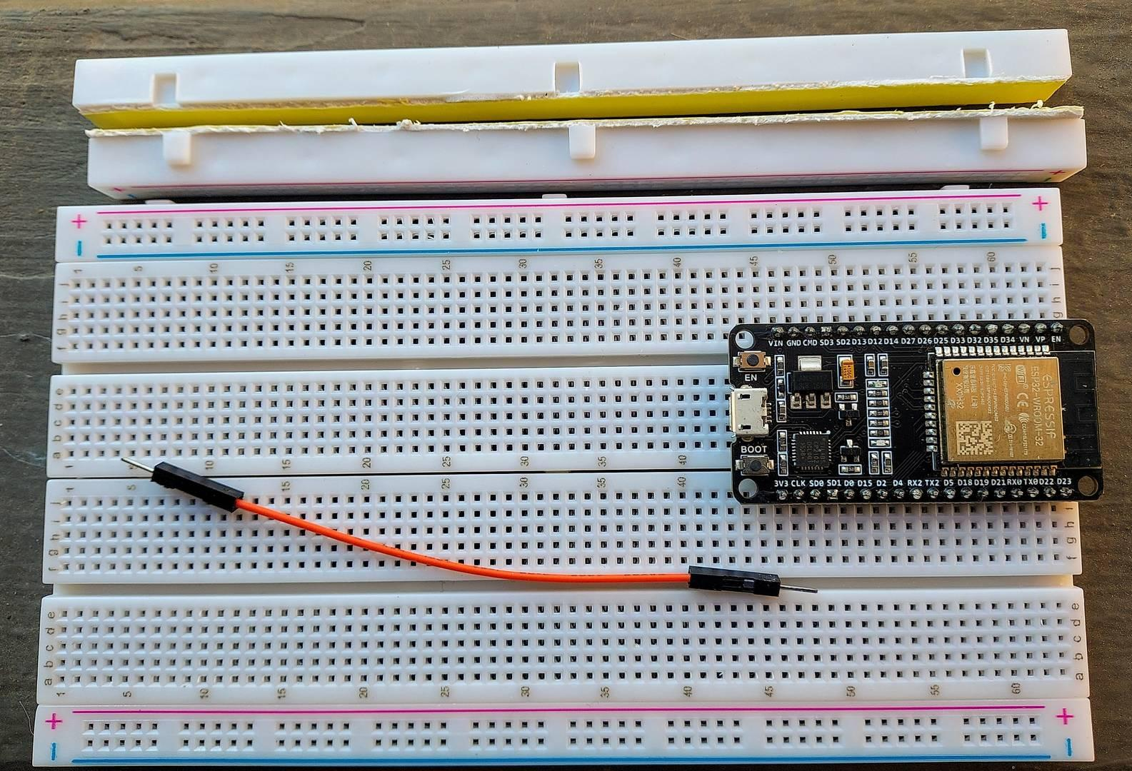

Step 2 :
Secondly, connect the power lines to the breadboard.
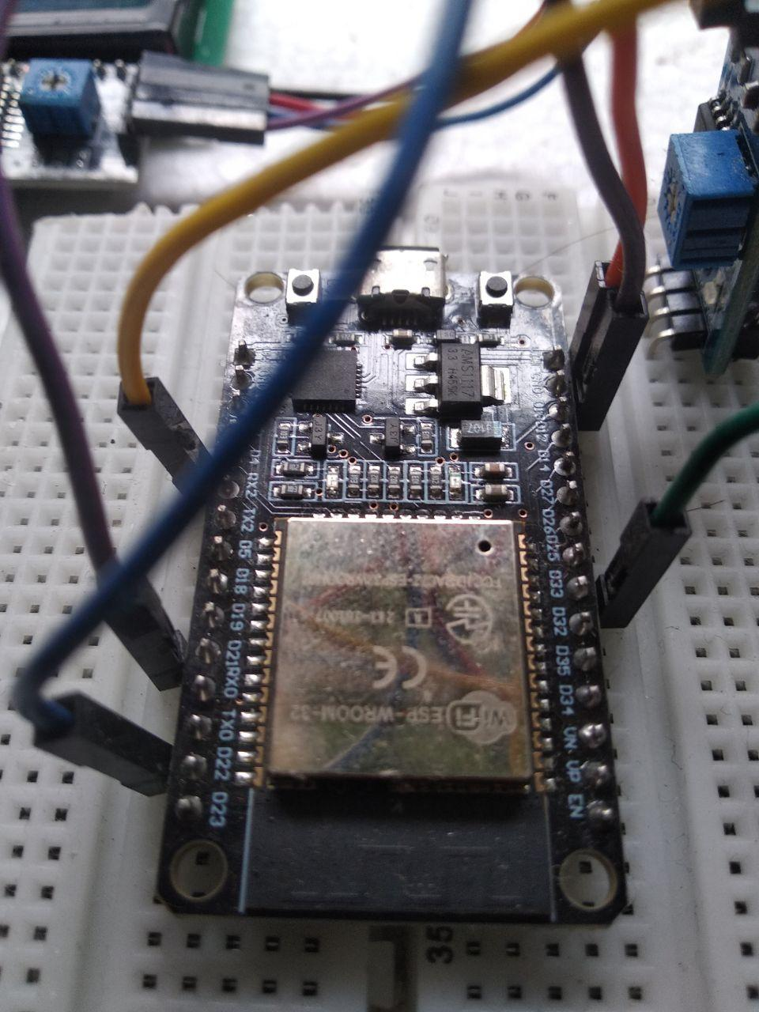

Step 3 :
Thirdly,Next, place the soil moisture sensor on the breadboard and connect it to the ESP32 board. For that, use the circuit diagram below.

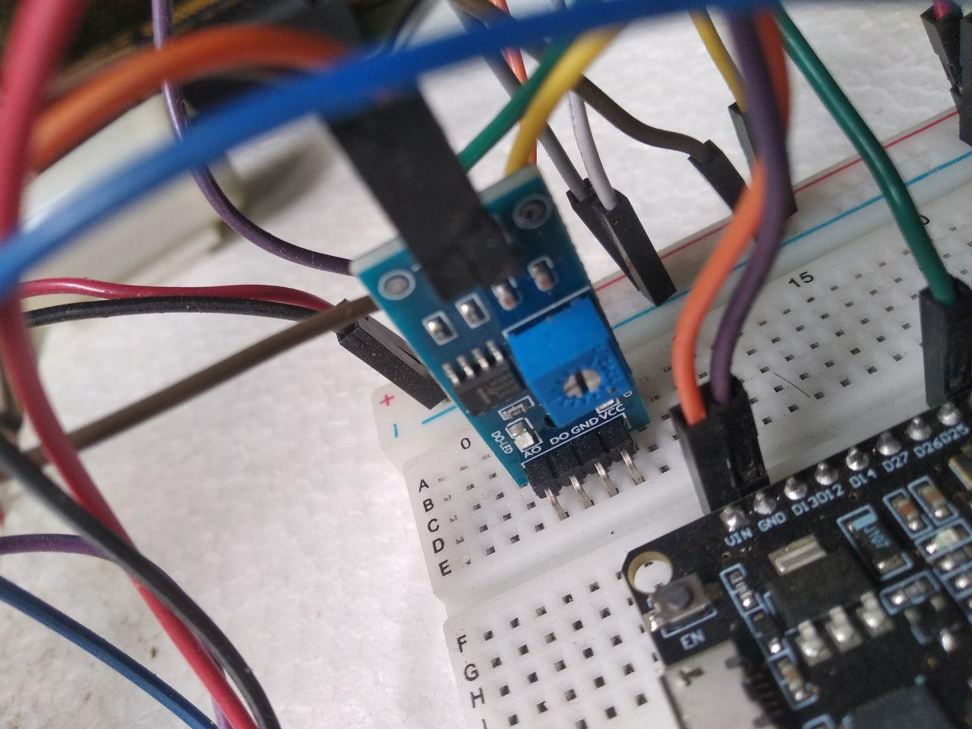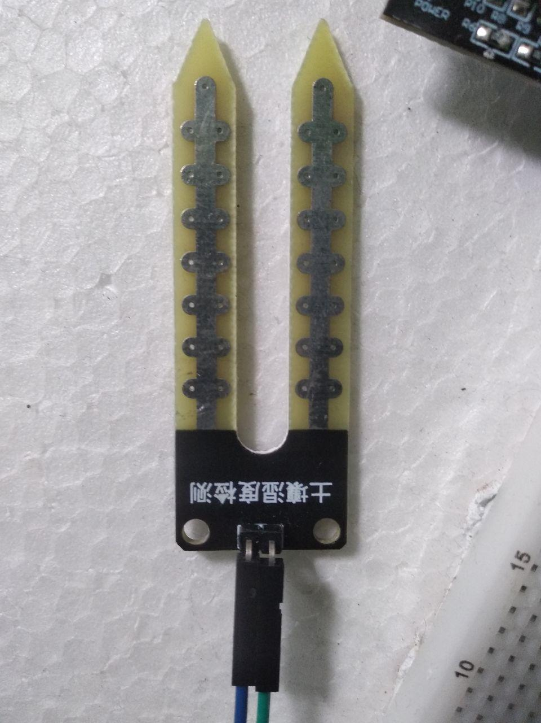

Step 4:
And then, connect the LCD screen and relay module to the ESP32 board.
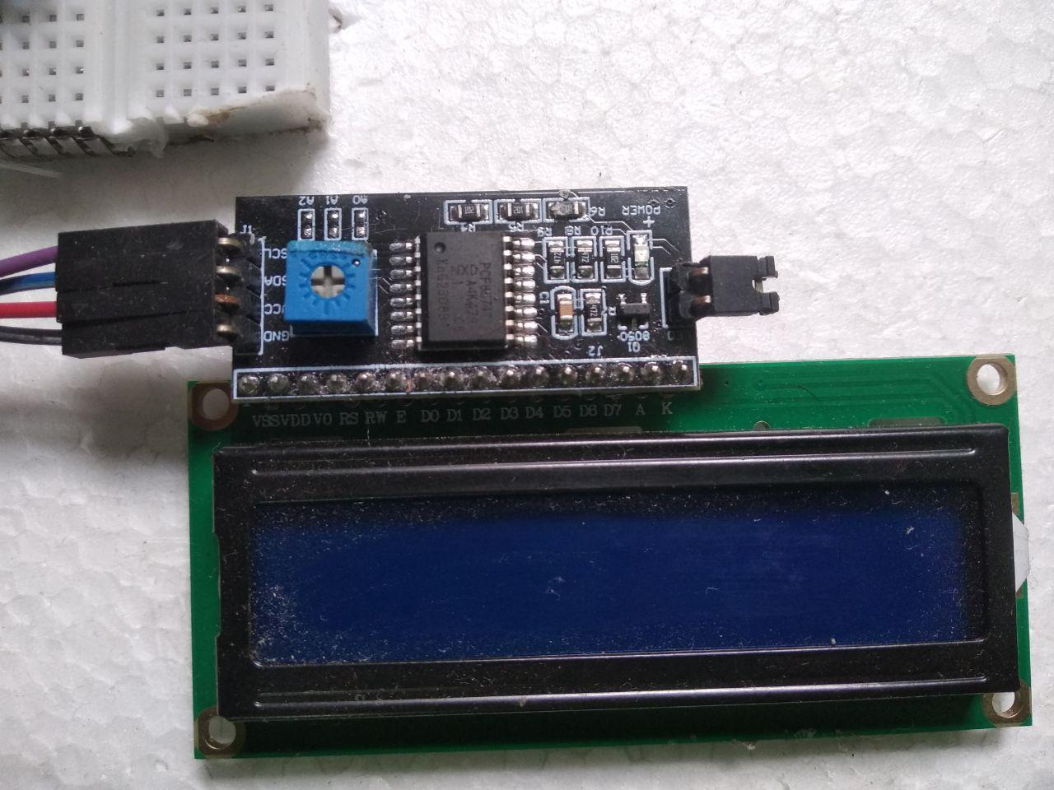

Step 5:
Now, let’s prepare the Blynk web dashboard. For that, follow the instructions below.
First, go to the Blynk website and create a new account using my Email. And then, log in to my account and create a new template. I have created it as a “Plant watering system”

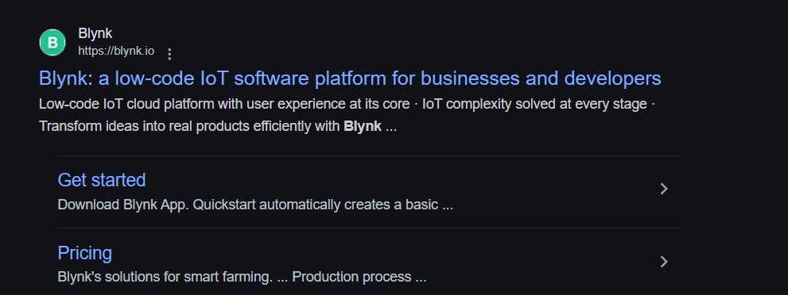
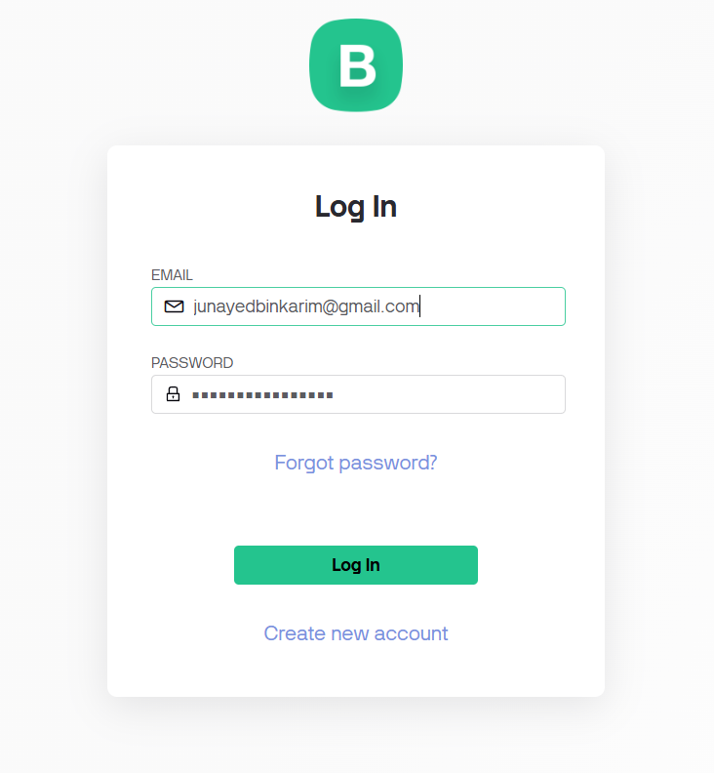
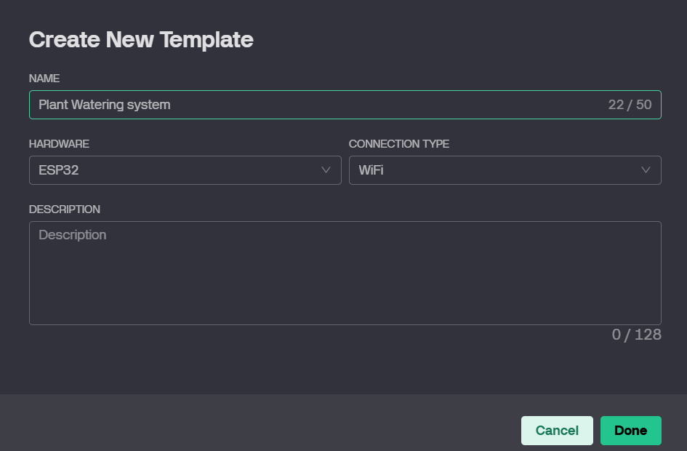

- Next, click the Detastrem tab and create two virtual pins. For that, use the instructions below.
- Name — Soil moisture value / PIN — V0 / MIN — 0 / MAX — 100
- Name — Water pump / PIN — V1 / MIN — 0 / MAX — 1
- And then, create a dashboard. I have used one button and one gauge for that. Next, click the gear wheel icons on the widgets and select the Data stream. After, click the save button.
- Now, click the search icon and create a new device. For that, select the template you created earlier.

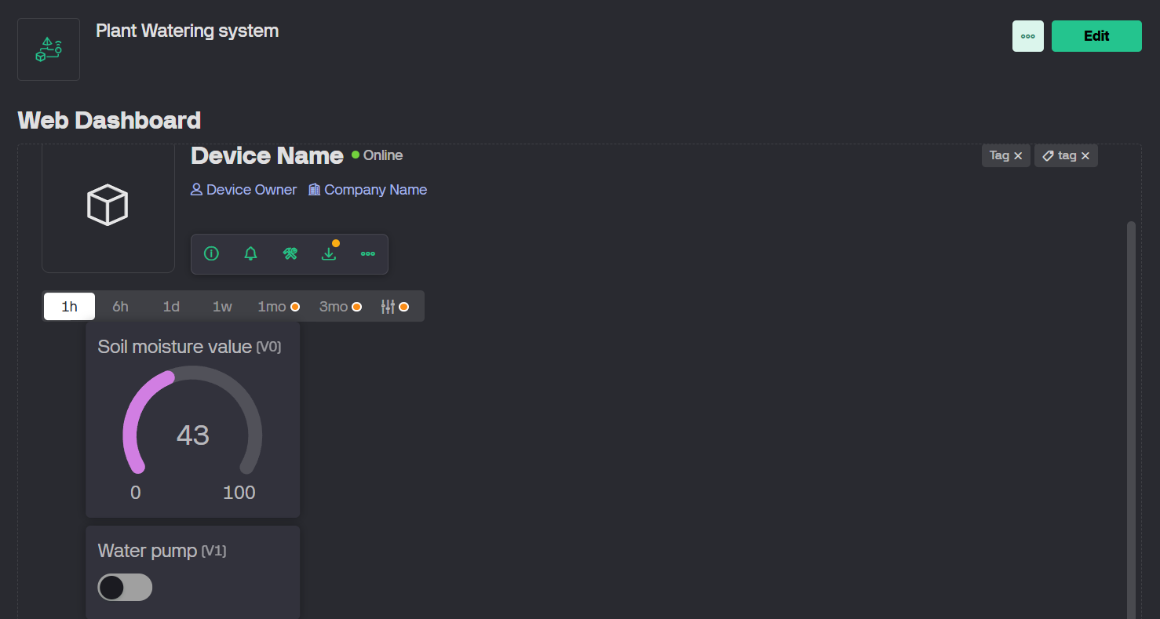
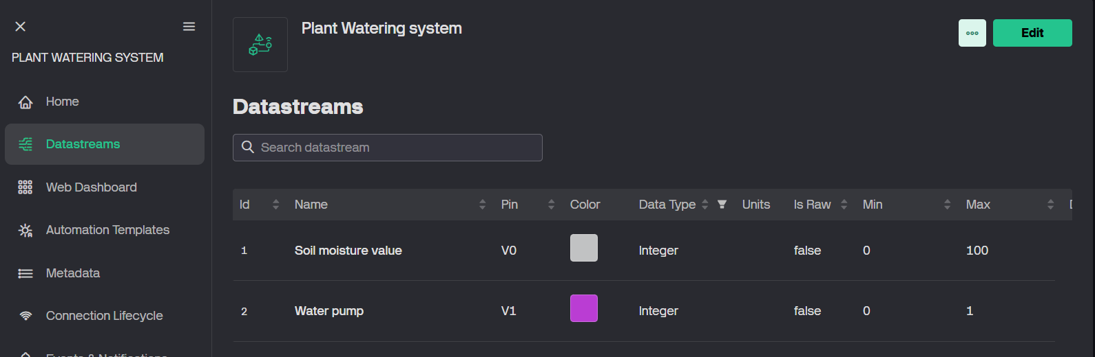
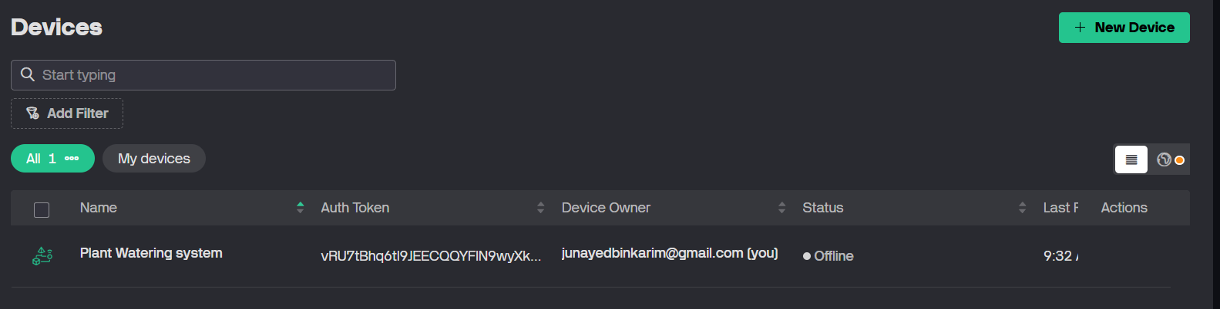
Ok, the Blynk web dashboard is ready for the project.

Step 6
Now, let’s prepare the Blynk mobile dashboard. For that, follow the instructions below.
- First, download and install the Blynk app on my smartphone. Then, log in to my account using your email and password.
- Next, select the template me created on the web dashboard. After, add one button and one gauge to the dashboard.

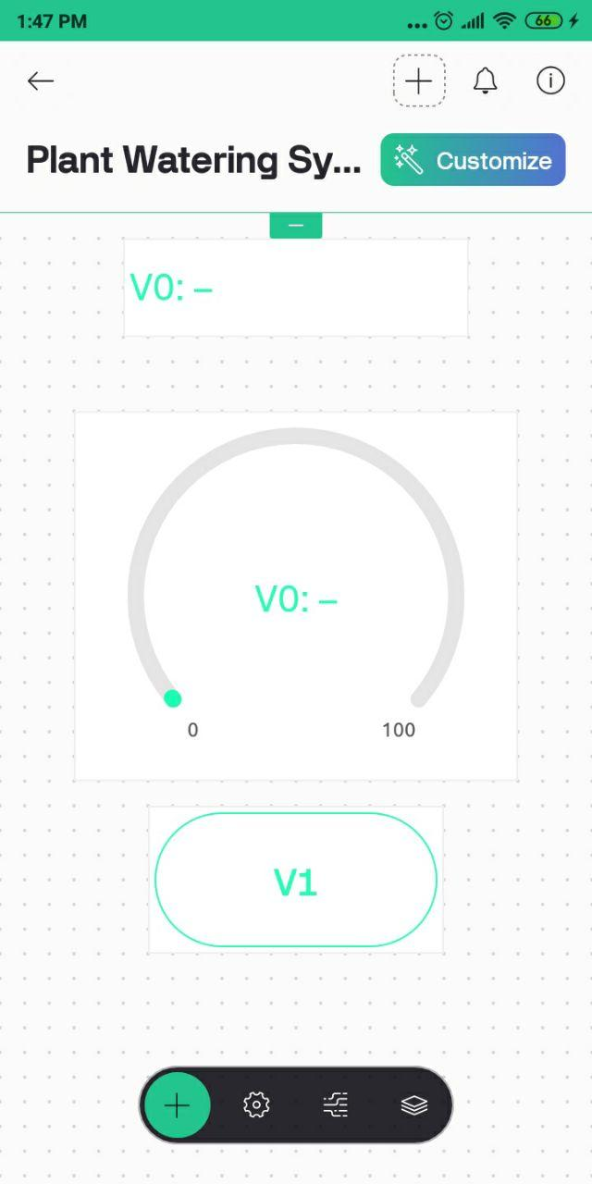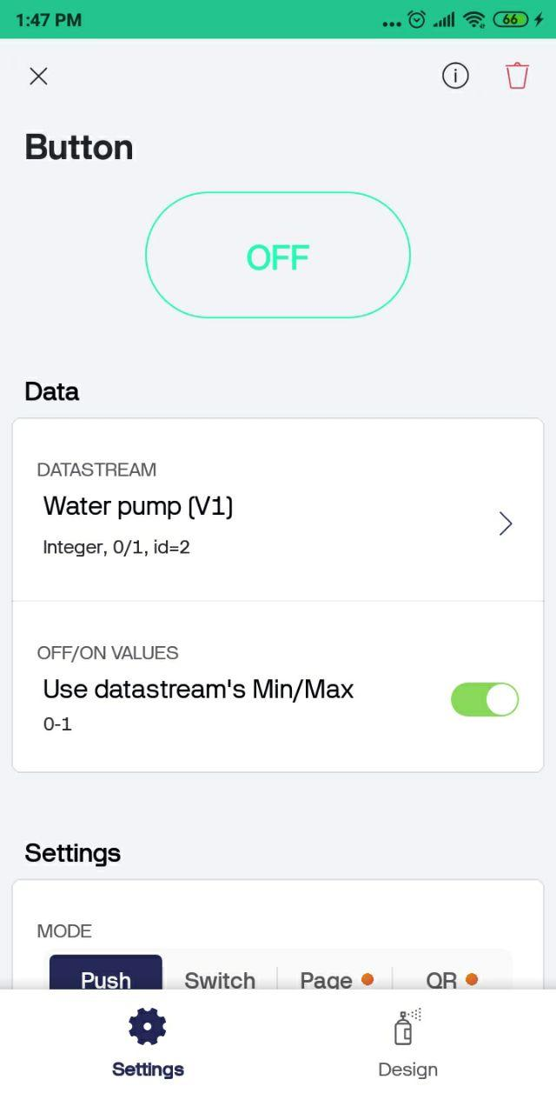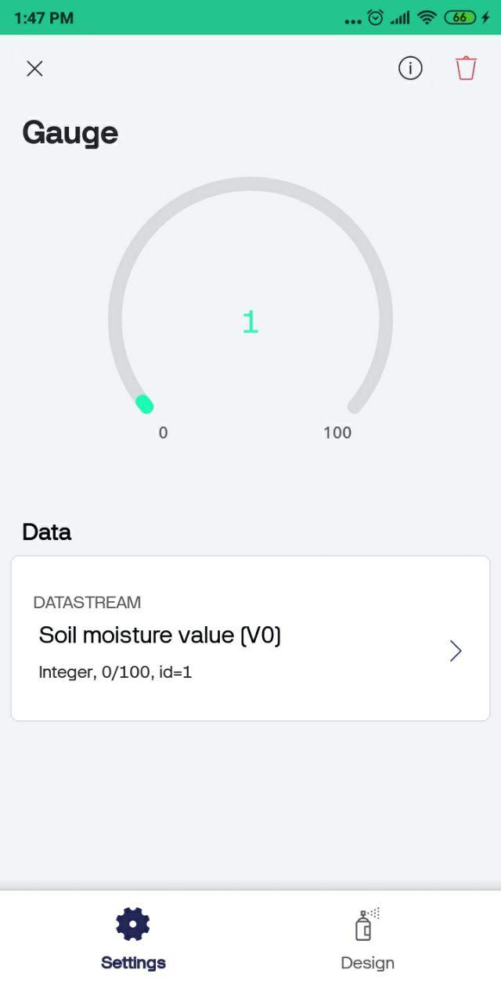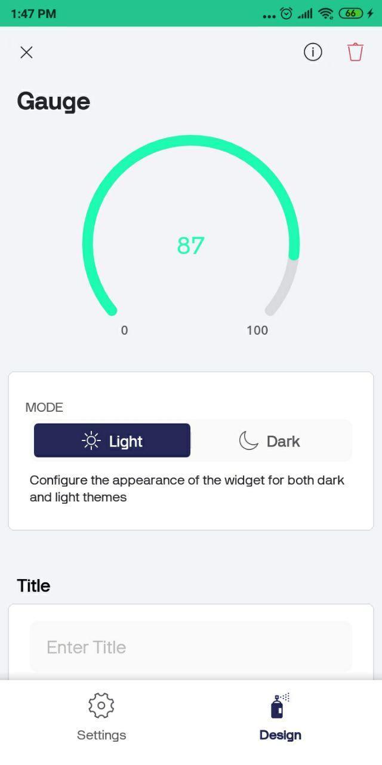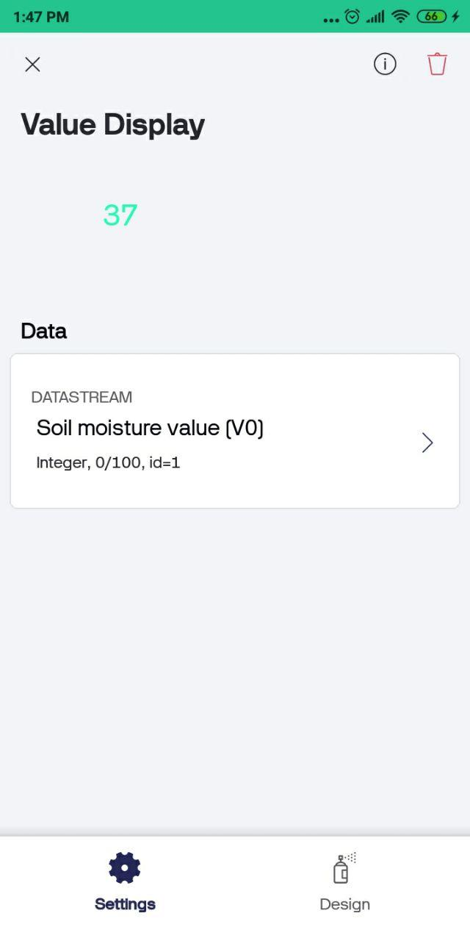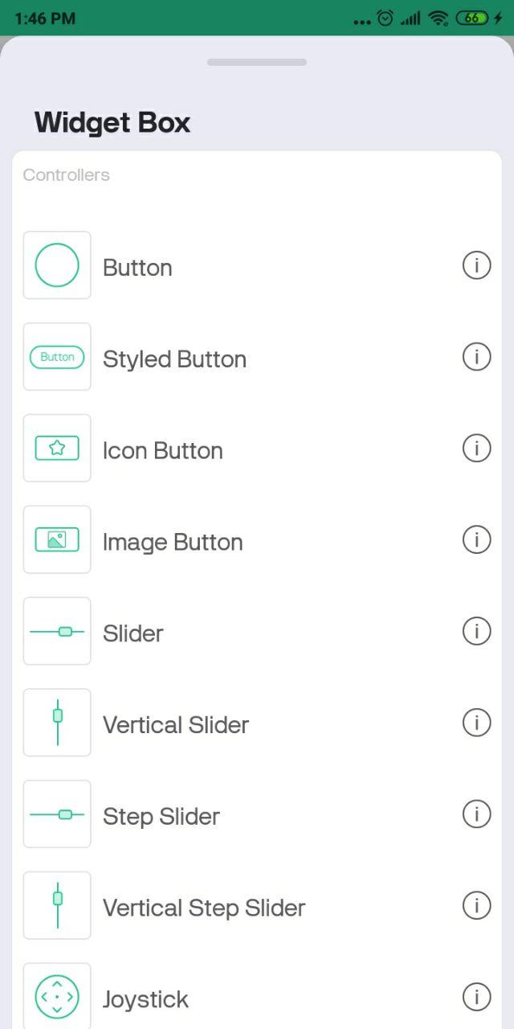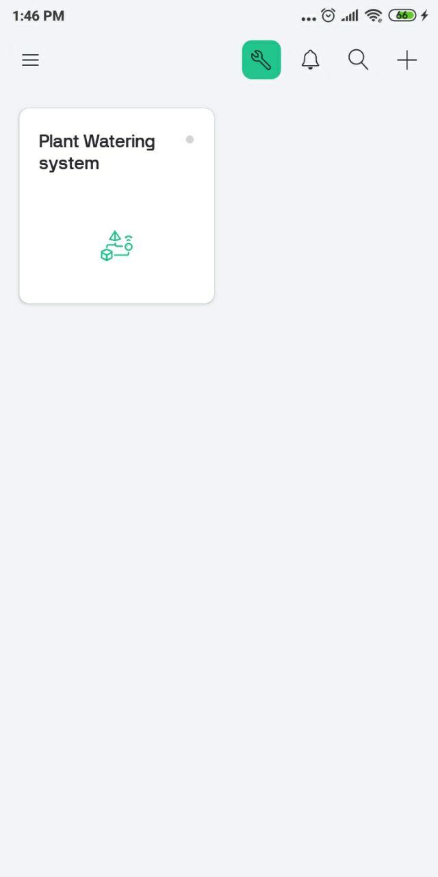

Step 7 :

Now, connect the ESP32 board to the computer. Then, the following program into my Arduino IDE.
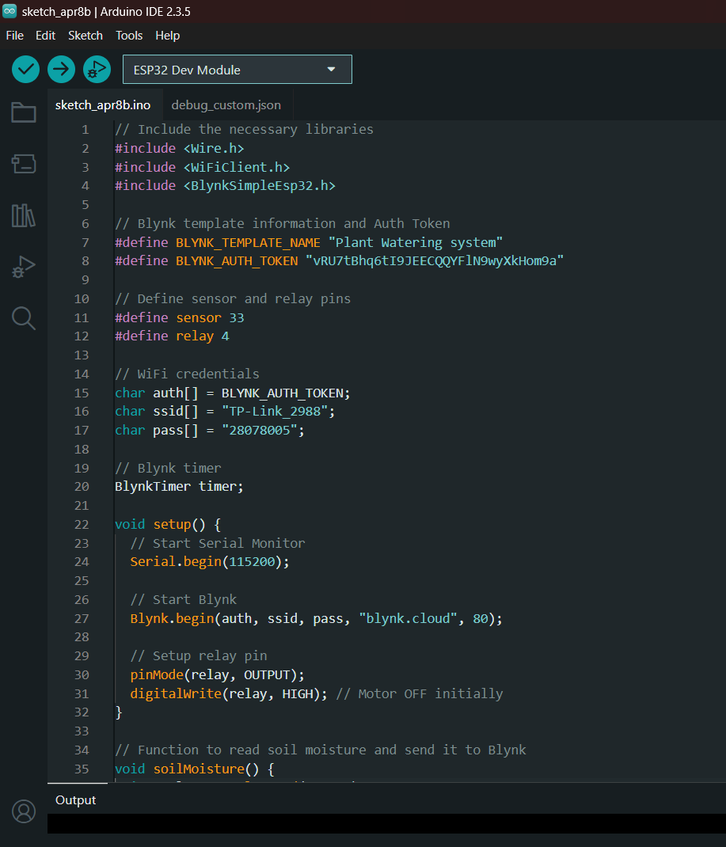

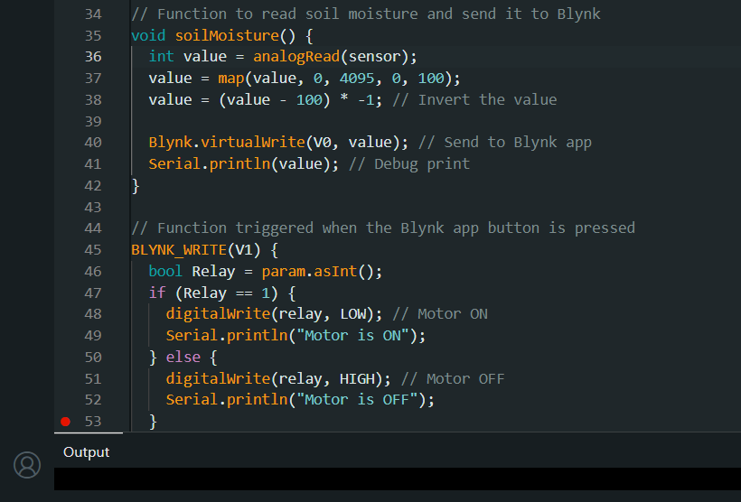

Step 8
Next, connect the water pump to the relay module. I have used the small water pump for that.
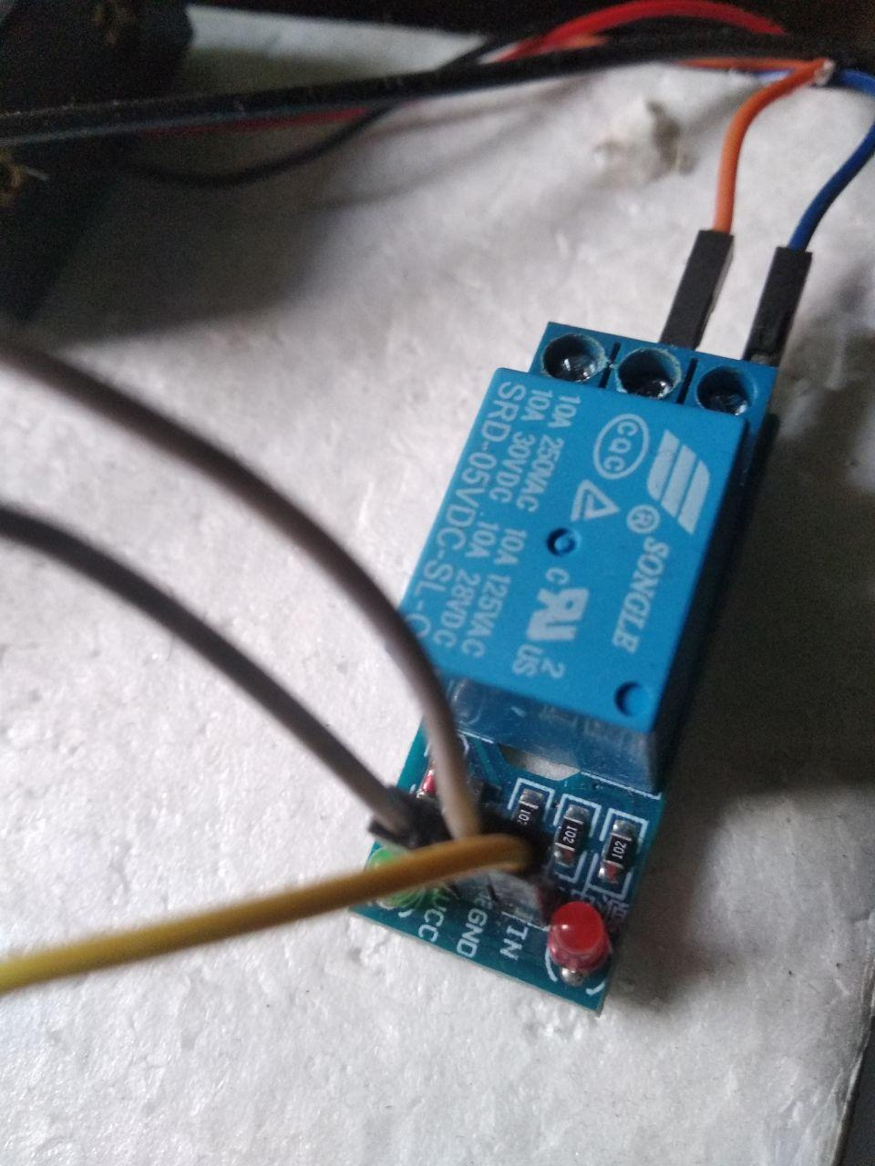

Step 9
Finally, provide an external 5VDC power supply to the ESP32 board.
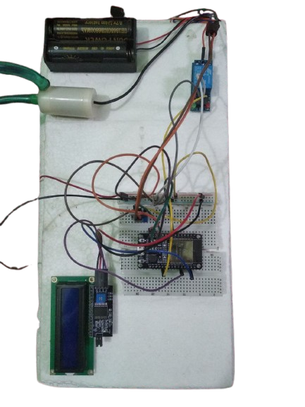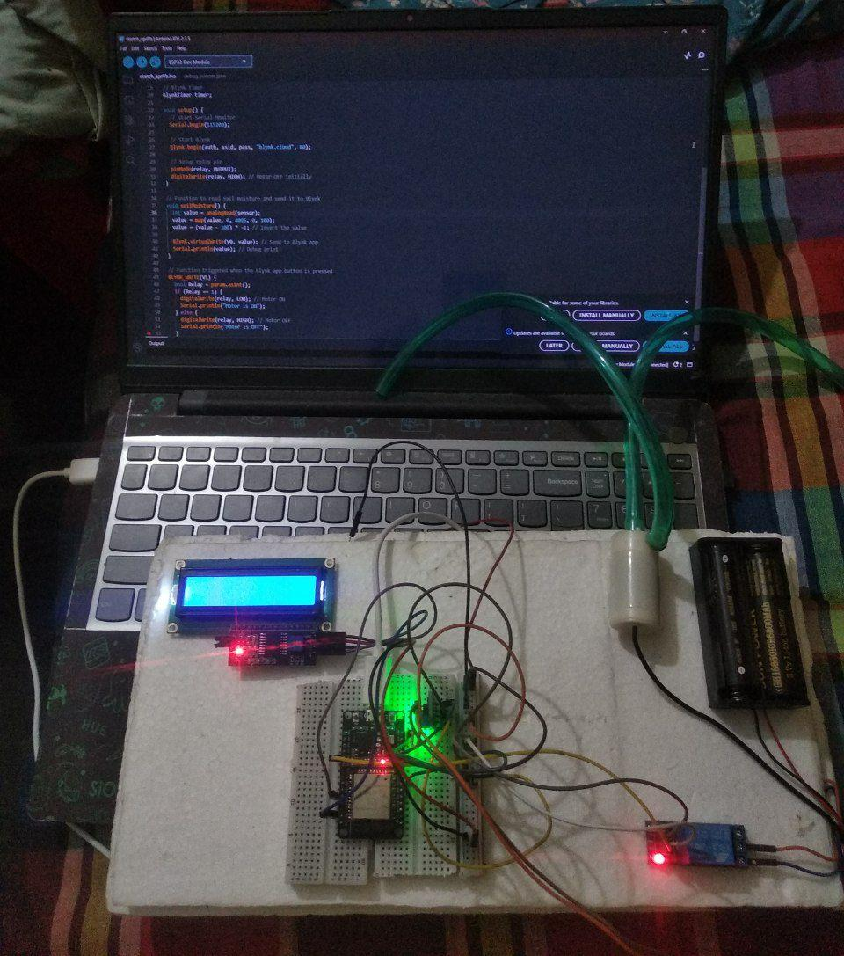

3.2 Performance Analysis
The system was tested to assess its performance in terms of speed, reliability, and energy efficiency. The analysis findings are as follows:
- Fast Sensor Response: The soil moisture sensor delivers updated readings in less than one second, enabling prompt decision-making.
- Reliable Actuation: The relay and pump reliably respond to moisture readings, ensuring correct watering behavior.
- Efficient Power Consumption: The system runs efficiently on Li-ion batteries, making it suitable for continuous operation in outdoor environments.
- Stable Connectivity: The ESP32 maintained a consistent Wi-Fi connection, enabling uninterrupted data transmission to the Blynk app.

3.3 Results and Discussion
The developed system met its intended goals effectively. Key outcomes include:
- Reduced Water Usage: Water consumption was optimized by activating the pump only when needed, based on actual soil moisture data.
- Automation and Remote Control: The irrigation process was fully automated, with the added benefit of remote control and monitoring through the Blynk app.
- Ease of Scalability: The system's modular design supports easy scaling for larger gardens or agricultural zones.
The project successfully demonstrated the potential of IoT in building smart, efficient, and user-friendly irrigation solutions.

Results Diagram
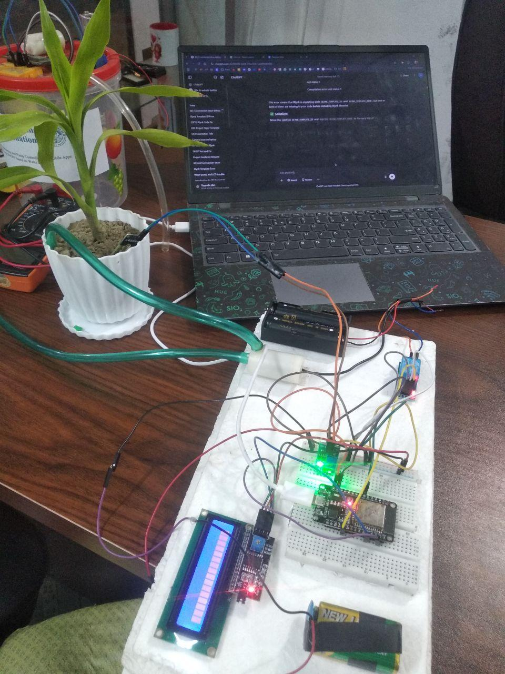

🎥 Project Video: Smart Garden Irrigation System

Chapter 4
Engineering Standards and Mapping

4.1 Impact on Society and Environment

4.1.1 Impact on Life
The implementation of this smart irrigation system offers tangible benefits in both personal and commercial contexts. For individual users, particularly urban dwellers with limited time and gardening knowledge, this system simplifies plant maintenance by automatically regulating water supply based on actual soil conditions. It eliminates the need for constant manual checks and scheduling, thus saving time, reducing effort, and ensuring healthy plant growth.
In agricultural settings or commercial gardens, the system enhances operational efficiency by ensuring crops receive optimal irrigation. This leads to better yield and resource management. The project's approach to automation can significantly improve productivity and reduce human labor requirements in small to medium-scale agricultural operations.

4.1.2 Impact on Society & Environment
This project addresses a critical environmental issue — water wastage — by ensuring water is used only when the soil needs it. The system encourages conscious consumption of natural resources, supporting broader goals of environmental conservation.
From a societal perspective, the project introduces users to modern agricultural technologies like IoT-based automation. It promotes awareness about smart farming practices and demonstrates how technology can support sustainable living. By using a smartphone application to control and monitor irrigation, it also bridges the gap between traditional farming and modern digital tools, making agriculture more accessible to the younger, tech-savvy generation.

4.1.3 Ethical Aspects
The ethical foundation of this project lies in its commitment to resource responsibility and accessibility. The system is designed to minimize water wastage — a moral obligation in water-scarce regions — and to encourage responsible environmental behavior.
Moreover, the use of open-source hardware (ESP32, Arduino) and free software tools (Arduino IDE, Blynk) ensures that this solution is financially and technically accessible to a wide range of users, including students, researchers, and low-income communities. This openness promotes knowledge sharing, collaboration, and inclusivity, aligning with ethical standards in technology development and use.

4.1.4 Sustainability Plan
Sustainability has been embedded into the project’s architecture through its modular and scalable design. This makes it adaptable for future upgrades without requiring a complete system overhaul. The following are potential future enhancements:
- Rainwater Detection Integration: By installing a rain sensor, the system could avoid unnecessary irrigation during natural rainfall.
- Weather API Integration: Using online weather forecast data via APIs, the system could make predictive decisions about irrigation needs.
- Zonal Watering Logic: Expanding the system to support multiple zones would allow separate moisture sensing and pump control in larger gardens or farms.
- Solar Power Compatibility: Integrating solar panels would make the system energy-independent and more eco-friendly.
These strategies ensure that the system remains relevant, efficient, and environmentally sound over time.

4.2 Project Management
Effective project management was essential to the successful completion of this system. The key aspects include:
- Budget Considerations:
The project was developed with zero financial investment by utilizing open-source tools and existing components. This demonstrates that impactful solutions can be built without high cost, encouraging others to replicate or enhance the system using accessible resources.
- Development Model:
The project followed an iterative development approach, meaning it was developed in small, testable stages. This model allowed continuous improvements based on testing and feedback, which led to better system performance and reduced the chances of critical failures during the final integration phase. Regular testing was done for sensor accuracy, pump control reliability, data transmission, and mobile interface responsiveness.

4.3 Complex Engineering Problem Mapping
This section highlights how the project outcomes align with Program Outcomes (POs) — key educational objectives in engineering education — by addressing complex engineering challenges:
Program Outcome (PO) | Application in Project
PO1: Engineering Knowledge | Applied principles of electronics, embedded systems, and microcontroller programming to automate irrigation using ESP32.
PO2: Problem Analysis | Analyzed and interpreted real-time soil moisture data to make automated decisions for efficient water management.
PO3: Design and Development of Solutions | Developed a user-friendly interface using the Blynk app that provides real-time monitoring and manual control for enhanced usability.
This mapping illustrates how the project goes beyond simple automation — it embodies real-world problem-solving, system integration, and user-oriented design, reflecting the core competencies expected from engineering graduates.

Chapter 5
Conclusion

5.1 Summary
This project successfully demonstrates the application of Internet of Things (IoT) in automating garden irrigation systems. By combining soil moisture sensors, an ESP32 microcontroller, and a mobile interface via the Blynk app, the system provides real-time monitoring and control of irrigation activities.
It ensures efficient water usage by automatically watering only when necessary, reducing manual effort and promoting sustainable gardening practices. The system’s design is modular, low-cost, and scalable — making it suitable for individual users, urban gardeners, and small-scale farmers alike.

5.2 Limitations
While the project fulfills its primary goals, it is subject to the following limitations:
- Dependence on WiFi Connectivity:
The system relies heavily on WiFi for remote monitoring and data transmission. Any interruption in connectivity may affect performance or user access.
- Limited Battery Capacity:
The use of standard Li-ion batteries restricts the system’s uptime. In continuous operation, especially in larger gardens, the power source may drain quickly.
- Static Thresholds for Irrigation:
The current system uses fixed soil moisture thresholds for activating irrigation. These thresholds may not adapt well to different plant types or weather conditions.

5.3 Future Work
To further enhance the functionality, intelligence, and adaptability of the system, several future enhancements are proposed:

1. Integration of Solar Power
Implementing solar panels can eliminate the dependency on traditional power sources, allowing for continuous operation in off-grid locations. This promotes long-term sustainability and energy efficiency.

2. Weather-Based Irrigation Decisions
Incorporating weather APIs or additional environmental sensors (e.g., temperature, humidity, rain) will enable the system to make more context-aware decisions, such as skipping irrigation during rainy or highly humid conditions.

3. Multi-Zone Garden Control
Future versions can include support for multiple soil zones, allowing the system to water different sections of a garden independently based on individual moisture readings. This would make the system scalable for larger gardens, greenhouses, or farms.

4. Machine Learning-Based Irrigation Optimization
A major future enhancement involves the use of Machine Learning (ML) techniques to:
- Learn plant-specific watering patterns over time by analyzing historical moisture data, temperature, humidity, and time-of-day.
- Predict optimal watering schedules using regression models or time series forecasting.
- Classify soil condition states (e.g., dry, moist, saturated) from sensor readings using supervised learning models.
- Enable adaptive thresholding, where the system adjusts its watering criteria dynamically rather than using static values.
ML can significantly improve the accuracy, efficiency, and adaptability of the system, making it smarter over time and more suited to complex gardening environments.

References
- Blynk IoT Platform Documentation: https://docs.blynk.io
- Arduino IDE Documentation: https://www.arduino.cc
- ESP32 Official Docs: https://docs.espressif.com

